**SMART POWER PLUS — RGB LED INDICATION LOGIC**

## Power ON and Hotspot (Wi-Fi Provisioning Ready)

* When the device is powered ON using 230V AC supply:
  + The MCU receives supply and starts booting.
  + The device automatically starts its own Wi-Fi Hotspot (Access Point mode).
  + The device is now ready for Wi-Fi provisioning using the companion mobile app.
* **LED Behaviour:**
  + The RGB LED blinks **Green** every 1 second.
  + This blinking pattern indicates:
    - The device is active.
    - Hotspot is running and waiting for Wi-Fi provisioning.
    - User should now connect using the mobile app.

## Wi-Fi Provisioning and Connection Status

* The user opens the mobile provisioning app and scans for available SPP devices (e.g., SPPA00001, SPPB00016) via SoftAP.
* The user selects the desired SPP device from the scan results and proceeds to the provisioning screen.
* The app displays available Local Wi-Fi networks (SSIDs); the user selects a network or enters it manually.
* The user enters the Wi-Fi password and starts the provisioning process.
* The device attempts connection to the selected local Wi-Fi network and reports provisioning status back to the app.
* **If Wi-Fi connection is successful:**
  + The LED pattern depends on the Wi-Fi signal strength:
    - **Good signal (≥ 60% strength):**
      * RGB LED turns **Green solid ON** (no blinking).
      * Indicates stable Wi-Fi connection with good strength.
    - **Weak signal (< 60% strength):**
      * RGB LED blinks **Green and Red alternately**, with each colour appearing every 1 second.
      * This warns the user that the Wi-Fi connection is weak, which could affect data transmission.

## Data Transmission to AWS IoT Core

* The device starts sending data to AWS IoT Core at the configured frequency.
* **If data is successfully sent to the cloud:**
  + The LED pattern depends on the Wi-Fi strength:
    - **Good Wi-Fi signal (≥ 60%) + successful data push:**
      * RGB LED blinks **Green and Blue alternately** (each colour appears every 1 second).
      * Indicates successful cloud communication and strong Wi-Fi.
    - **Weak Wi-Fi signal (< 60%) + successful data push:**
      * RGB LED blinks in a sequence: **Green → Red → Blue**, with each colour appearing for 1 second before changing to the next.
      * Indicates successful cloud communication but warns about weak Wi-Fi strength.
* This ensures the user is aware of both the data transmission status and Wi-Fi quality.

## Wi-Fi Disconnection

* At any point during operation:
  + If the Wi-Fi connection is lost (disconnected from the router or access point):
    - RGB LED blinks **Red continuously**, every 1 second.
    - This indicates:
      * The device is offline and not connected to Wi-Fi.
      * No data is being sent to the cloud.
* Once Wi-Fi reconnects:
  + The LED pattern updates according to the current Wi-Fi strength and data transmission status.

## Quick LED Pattern Reference

|  |  |
| --- | --- |
| **Condition** | **LED Pattern** |
| Power ON + Hotspot active | Green blink (1 sec interval) |
| Wi-Fi connected (≥ 60% signal) | Green solid ON |
| Wi-Fi connected (< 60% signal) | Green & Red blink alternately (1 sec interval) |
| Data push success + good Wi-Fi | Green & Blue blink alternately (1 sec interval) |
| Data push success + weak Wi-Fi | Green → Red → Blue blink sequence (1 sec each) |
| Wi-Fi disconnected | Red blink (1 sec interval) |

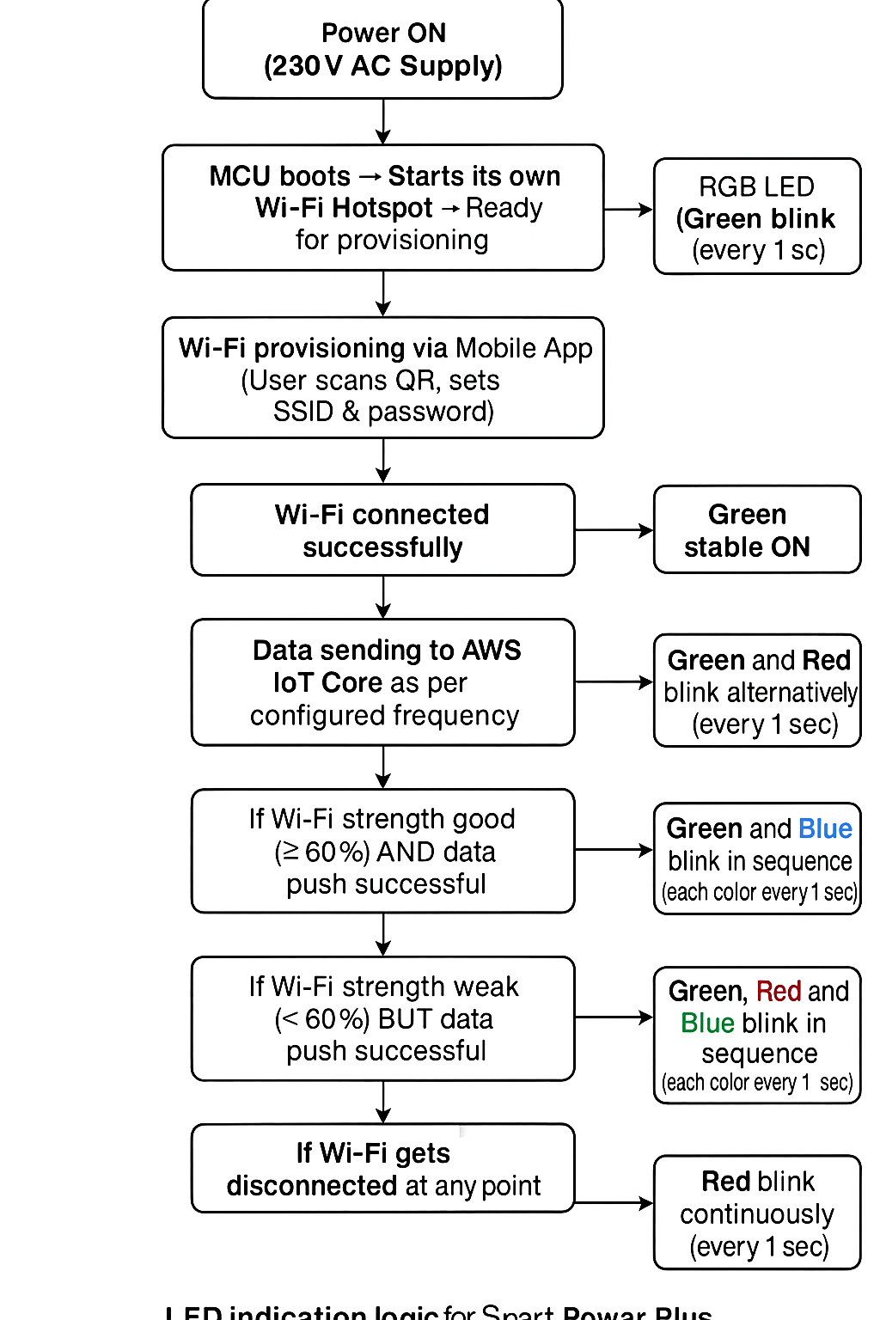

## How this helps the user

* The LED patterns provide immediate visual feedback:
  + On device readiness (hotspot, provisioning).
  + Wi-Fi connection quality.
  + Data push status to AWS IoT Core.
  + Alerts for disconnection or weak connectivity.